**Understanding the Career Aspiration of Gen Z**

**Sathwik Bhat**

**Introduction**

Generation Z, often abbreviated as Gen Z, is the generation that comes after Millennials (also known as Gen Y) and includes individuals born between the mid-1990s and the early 2010s, although the exact years vary depending on the source. This means that in 2023, the oldest members of Gen Z are in their late 20s, while the youngest are still in early childhood.

Gen Z is sometimes also referred to as the Information Generation, Post-Millennials, or home landers, among other names. This generation is known for growing up in a world shaped by digital technology, social media, and globalization. They are often described as being more diverse, tolerant, and socially aware than previous generations, and more likely to value individualism and entrepreneurship.

As a group, Gen Z is also facing unique challenges and opportunities, such as navigating a rapidly changing job market, grappling with issues like climate change and political polarization, and harnessing the power of technology to create positive change.

However, research shows that Gen Z may be struggling with engagement at work. According to a 2022 Gallup Poll, 54% of Gen Z employees, slightly higher than any other generation, are ambivalent or not engaged at work. As such, it is essential for managers to support their Gen Z employees and earn their full engagement.

**Analysis 5 W & O**

* **Who**
* **What**
* **Where**
* **When**
* **Why**
* **Objective**

**Who Are All Affected?**

* **Employers**:
* Employers who fail to understand the career aspirations of Gen Z may find it challenging to attract and retain young talent. Gen Z workers value meaningful work, flexible schedules, and work-life balance. Employers who fail to provide these benefits may find it difficult to retain Gen Z employees and compete with companies that do.
* **Individuals**:
* Gen Z individuals who are unsure about their career aspirations may experience uncertainty and anxiety about their future. They may feel pressure to make decisions about their careers, but without a clear sense of direction, they may struggle to make informed choices.
* **Educational institutions**:
* educational institutions that fail to understand Gen Z career aspirations may struggle to provide relevant education and training. Gen Z individuals are interested in learning practical and applicable skills in the real world. Institutions that fail to provide such education may find attracting and retaining students difficult.
* **Society as a whole**:
* Gen Z is the largest generation in history, and their career aspirations will shape the future The failure to understand the hopes and aspirations of this generation may make it difficult for society to adapt to the changing needs of the challenges.

**What Happening**

Young people today are more likely to do jobs, but they are also looking for stability by pursuing careers as CEOs, doctors, and engineers.

* **Not Focused:**

Gen Z is not focused on any goal, they are more fuzzy, Unclear about the future. so they need correct Guidance for the Future.

* **Mimicking the others :**

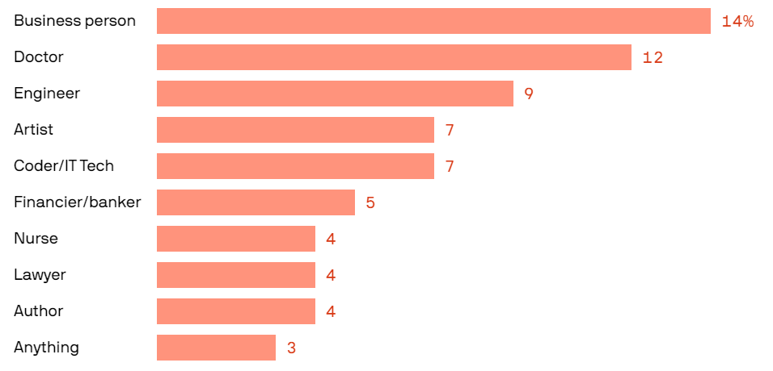Gen Z is based on their parents’ guidance and sees the other person’s lifestyle or status (Car, House, other) they think that making this career would happen not to look into their passion. or interested area.

**More Career Paths Chosen by Gen Z**

**Where is this Happening?**

* **Lack of exposure to different careers:**
* This can be due to limited resources, lack of guidance, or simply not knowing where to start. people may not have had the opportunity to explore a wide variety of career options
* **Changing job market:**
* The job market is constantly evolving and it can be difficult for anyone, including Gen Z, to keep up with the latest trends and demands. This can make it challenging to identify which skills and qualifications are most valuable in the job market.
* **Pressure to choose the "right" career:**
* Many young people feel pressure to choose a career that is seen as prestigious, financially lucrative, or socially acceptable. This pressure can make it difficult to explore and pursue careers that may be personally fulfilling but are not seen as "safe" choices.
* **Personal uncertainty:**
* Some young people may simply be uncertain about their interests, strengths, and goals. This can make identifying a career path that aligns with their unique skills and passions is challenging.

**When Is Happening?**

Gen Z is coming of age during a time of significant economic, social, and political instability. They are experiencing the impacts of climate change, witnessing widening income inequality, and navigating a rapidly changing job market. These factors, among others, may lead some Gen Z individuals to feel unsure about their place in the world and what they want to achieve in the future.

* **Ai Affects:**

Because of Ai more of the job market is suffering from large Layoffs Repetitive tasks are done by Ai and More Dant entries, Accounts maintenance, the Manufacturing sector, and more Machines and AI replacing humans.

* **Economy Affects:**

Because of Economy Crises like Recessions, the economy struggles. This Affects leads to more company are layoff’s employees and also more startups closing, this affecting more gen Z

**Why Is Happening**

* **Economic Instability:**

Gen Z is entering the workforce during a period of economic instability, including the aftermath of the 2008 financial crisis and the ongoing COVID-19 pandemic. This has led to a competitive job market, and many Gen Z workers struggle to find secure and well-paying jobs.

* **Technological Disruption:**

The rapid pace of technological change has disrupted many traditional career paths and industries. Many Gen Z workers must adapt to new technologies and learn new skills in order to stay competitive in the job market.

* **Changing Attitudes:**

Gen Z tends to have different attitudes and values than previous generations, including a desire for work-life balance and a greater emphasis on social responsibility. These attitudes may not always align with the expectations of employers or the demands of certain industries.

* **Educational Debt:**

Many Gen Z workers carry significant educational debt from pursuing higher education, which can limit their ability to take risks or pursue entrepreneurial ventures.

**Conclusion:**

Overall, we understand that using analysis of the 5 w the Gen Z are more Struggling and they have some advantages also using technology make work easier. In the Competitive world individuals also have more knowledge and more understanding the current trend goes with the Current trends. So, Gen Z has more Advantages Compare to Other Generations. Gen Z has a Chance to get old and new trends So These Generations are more Experienced.